**Executive Summary**

The purpose of this experiment was to accomplish two tasks; to analyze a Controller under three different modes of operation: Proportional (P), Proportional + Integral (PI), and Proportional + Derivate (PD), and using benchmark parameters of Proportional Control to improve the output of the latter two modes of operation.

The second task involved combining of all three modes of operation to achieve a stable Proportional + Integral + Derivative (PID) Controller, and, using one of three methods of tuning: trial-and-error, Ziegler-Nichols “Ultimate Gain” Method or Ziegler-Nichols “Process Reaction” Method, to improve the closed loop response to find the best parameters to meet given specifications.

Certain specifications were to be obtained from the controllers under different gains. The specifications included Percent Overshoot (PO), Settling Time, Rise Time, and Steady State Error for both step and ramp input. In the first part of the lab, all the transfer functions of each controllers were tested with different gain values and the PI and PD controllers were tested on different time constants as well. It is observed that the specifications will change from gain to another and from time constant as well as the difference between each controller compared to the benchmarked response. Further details will be supported within the report for clarification purposes.

In the last part of this experiment, the three controllers wee all summed up in a parallel connection to come up with what is called the PID controller. The “Ultimate Gain” Method was chosen for designing/tuning the controller which states manipulating the value of the gain of the P controller and getting the period off the plot and then using the modified equations to obtain both integral and derivative time constants that can be achieved of the PID. For our case, the value of the gain of the P controller was 7.1946 and the chosen value was the benchmarked gain which was 3.05 V/V.

**Part 1: Exploring Control Modes (P, PI and PD)**

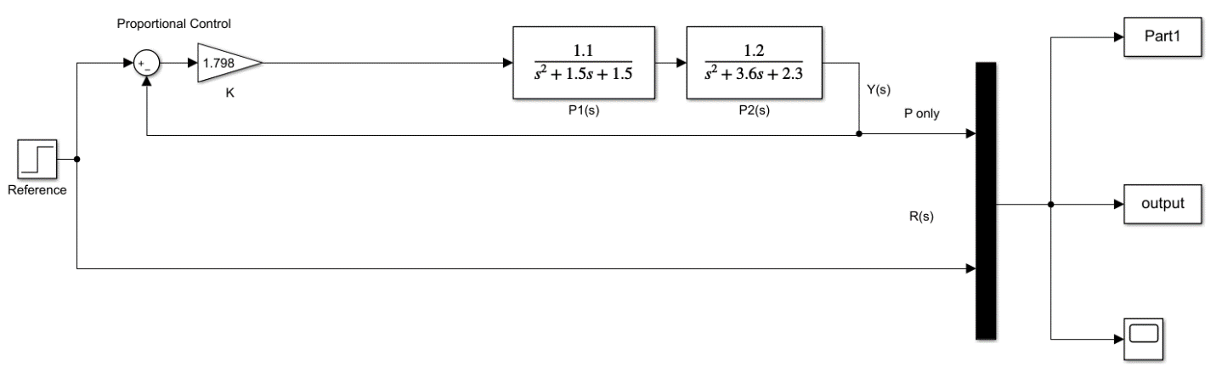**Proportional (P) Control**

Figure : P Controller SIMULINK Diagram

The transfer function used is as follows:

$$G_{CL}\left(s\right)=\frac{1.32K_{P}}{s^{4}+5.1s^{3}+9.2s^{2}+8.85s+3.45+1.32K_{P}}$$

The characteristic equation is: $s^{4}+5.1s^{3}+9.2s^{2}+8.85s+\left(3.45+1.32K_{P}\right)$

It was found that the Critical Gain ${(K}_{Crit})$ is 7.198.

Different gain ${(K}_{P})$ values were used, and the results were tabulated in the following table:

Table 1: Steady State Error of P Controller under Different Operational Gain

|  |  |  |
| --- | --- | --- |
| **Proportional Gain Value** “ $K_{P}$” | **Steady State Output Value** “yss” | **Steady State Error** **Percentage** “ess”(%) |
| 1 | 0.2768 | 73.32 |
| 2 | 0.4335 | 56.65 |
| 3 | 0.5345 | 46.55 |
| 4 | 0.6049 | 39.51 |
| 5 | 0.6568 | 34.32 |
| 6 | 0.6945 | 30.55 |
| 7 | 0.7948 | 20.52 |

The steady state error percentage was calculated using the following equation:

$$e_{ss}=\frac{r_{ss}-y_{ss}}{r_{ss}}×100\%$$

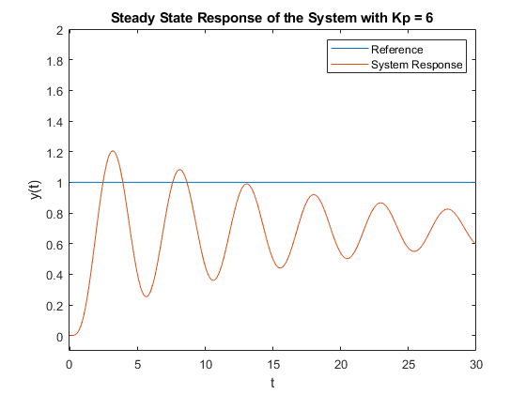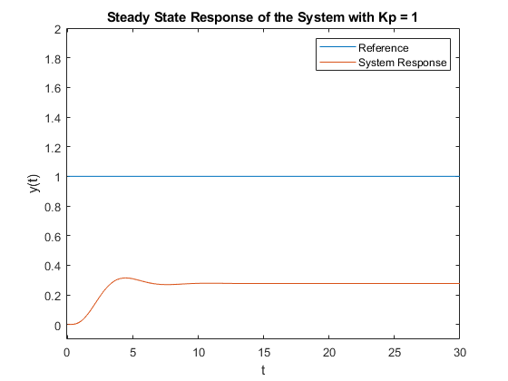A ramp response was also studied to determine the system steady state response parameters outside of a step response. The results are as follows:

Figure 4: Steady State Response of P Controller with Unit Ramp Reference

Figure 2: Steady State Response of P Controller with Gain = 1

Figure 3: Steady State Response of P Controller with Gain = 6

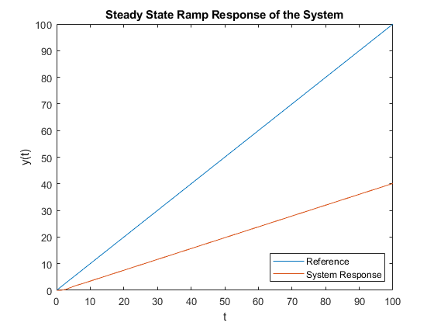As seen in the figure above, the ramp response is not an accurate way of determining response parameters as it will have a velocity constant, $K_{v}$, of infinity due to the infinitely different slopes between the two signals. This is situation is modeled by the equation:

$$K_{v}=\lim_{s→0}{s∙G_{open}\left(s\right)}=\lim_{s→0}{\frac{sK_{p}\left(1.1\right)\left(1.2\right)}{\left(s^{2}+1.5s+1.5\right)\left(s^{2}+3.6s+2.3\right)}}=\frac{0}{\left(0+0+1.5\right)\left(0+0+2.3\right)}=0$$

$$e_{ss}=\frac{1}{K_{v}}=\frac{1}{0}=∞$$

Furthermore, a unit step response can be used to measure the transient response of the system. These transient response parameters include settling time, percentage overshoot and peak time values. The table below describes the parameters at different $K_{P}$ values.

Table 2: Transient Parameters of P Controller under Different Operational Gain

|  |  |  |  |  |
| --- | --- | --- | --- | --- |
| **Proportional Gain Value** “ $K_{P}$” | **Percentage Overshoot** “PO” (%) | **Overshoot Peak Value** “PO” | **TSettle 2%** (s) | **TRise 0-100%** (s) |
| 1 | 13.44 | 0.3140 | 8.3612 | 3.3445 |
| 2 | 27.34 | 0.5520 | 10.70 | 3.01 |
| 3 | 40.29 | 0.7498 | 15.38 | 2.6756 |
| 4 | 51.78 | 0.9181 | 22.40 | 2.3411 |
| 5 | 62.94 | 1.0701 | 34.11 | 2.3411 |
| 6 | 72.37 | 1.1971 | 67.89 | 2.0067 |
| 7 | 67.2623 | 1.3294 | 99.66 | 2.0067 |

To calculate the Percentage Overshoot, the following equation was used:

$$PO=\frac{y_{max}-y_{ss}}{y_{ss}}×100\%$$

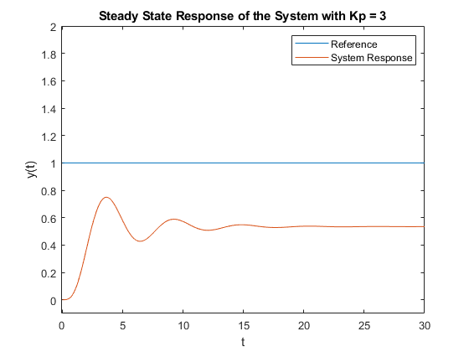Note that placing reference lines within the MATLAB scope plot and using the cursor function to solve for the time in which the 2% settling occurs was the technique used to determine this settling time. An example plots with proportional gain of 3 can be found below:

Figure 5: Steady State Response of P Controller with Gain = 3

Table 3: Effect on Transient Response of P Controller with Change in Gain

|  |  |  |  |  |  |
| --- | --- | --- | --- | --- | --- |
| **Proportional Controller Gain** | **ess Step** (%) | **ess Ramp** (%) | **PO** | **TSettle 2%** (s) | **TRise 0-100%** (s) |
| Increase | Decrease | Decrease | Increase | Increase | Decrease |
| Decrease | Increase | Increase | Decrease | Decrease | Increase |

“Benchmarking” the System

The system was “benchmarked” using the “Quarter Decay” response of the Proportional Controller [1]. The Operational Gain to achieve Quarter Decay was done through Trial-And-Error such that:

$$Quarter Decay=\frac{1}{4}=\frac{Amplitude of Second Overshoot}{Amplitude of First Overshoot}$$

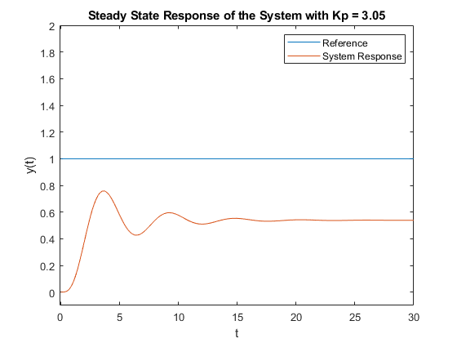

Figure 6: Steady State Response of P Controller when Kp = 3.05

Table 4: Transient Parameters of Benchmarked P Controller

|  |  |  |  |  |  |  |
| --- | --- | --- | --- | --- | --- | --- |
| **Proportional Gain Value** “ $K_{P}$” | **Percentage Overshoot** “PO” (%) | **Overshoot Peak Value** “PO” | **Steady State Output Value** “yss” | **Steady State Error** **Percentage** “ess”(%) | **TSettle 2%** (s) | **TRise 0-100%** (s) |
| 3.05 | 40.88 | 0.7587 | 0.5386 | 46.14 | 15.38 | 2.6756 |

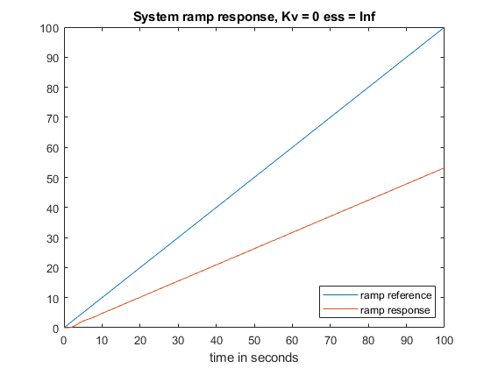

Figure 7: Ramp Response for Benchmark

**Proportional + Integral (PI) Control**

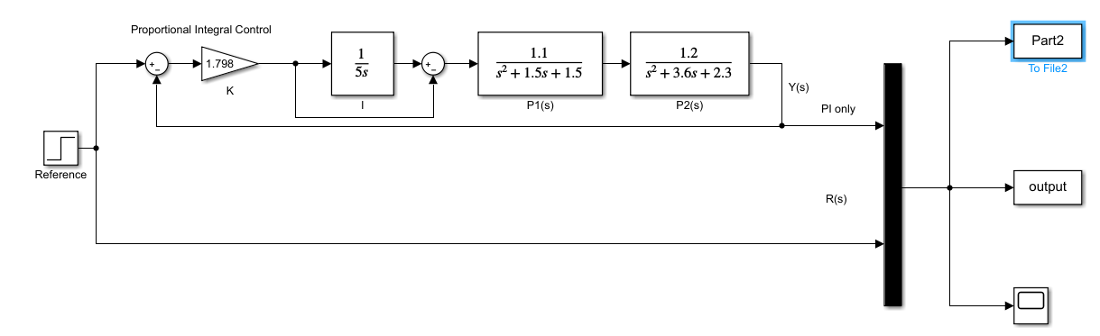

Figure 8: PI Controller SIMULINK Diagram

Proportional + Integral (PI) is used to create a more optimal and accurate system response. The same principles applied to Proportional Control will be applied here again to study the PI response. It is important to note that a value of $τ_{i}=5$ was used to conduct these studies.

The transfer function used is as follows:

$$G_{CL}\left(s\right)=\frac{6.6K_{PI}s+1.32K_{PI}}{5s^{5}+25.5s^{4}+46s^{3}+44.25s^{2}+17.25s+6.6K_{PI}s+1.32K_{PI}}$$

The characteristic equation is: $5s^{5}+25.5s^{4}+46s^{3}+44.25s^{2}+17.25s+6.6K_{PI}s+1.32K_{PI}$

It was found that the Critical Gain ${(K}_{Crit})$ is 6.247.

Different gain ${(K}_{P})$ values were used, and the results were tabulated in the following table:

Table 5: Steady State Error of PI Controller under Different Operational Gain

|  |  |  |
| --- | --- | --- |
| **Operational Gain Value** “ $K_{P}$” | **Steady State Output Value** “yss” | **Steady State Error** **Percentage** “ess”(%) |
| 1 | 1 | 0 |
| 2 | 1 | 0 |
| 3 | 1 | 0 |
| 4 | 1 | 0 |
| 5 | 1 | 0 |
| 6 | 1 | 9.43 |

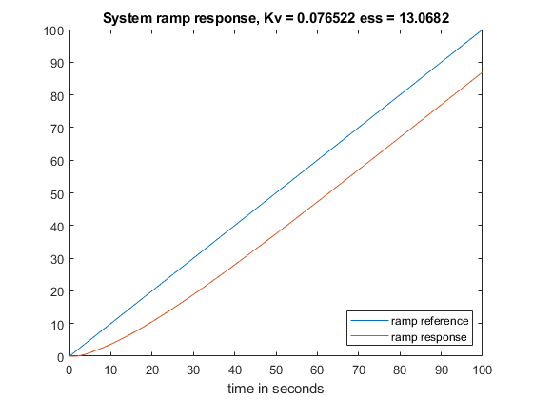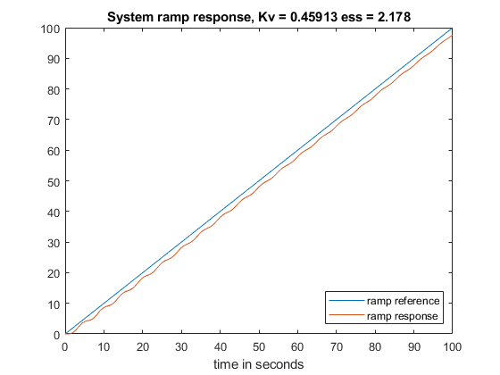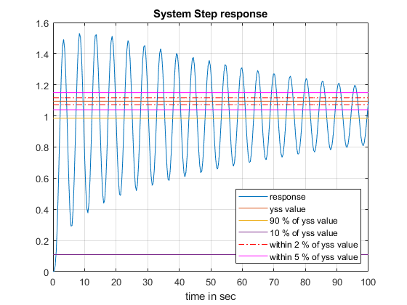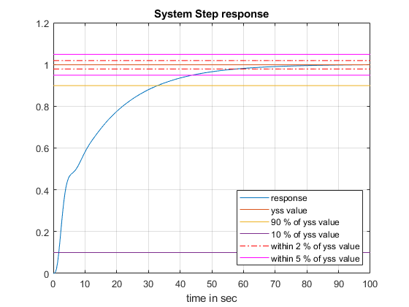

Figure 11: System Ramp Response of PI Controller with Operational Gain = 1

Figure 12: System Ramp Response of PI Controller with Operational Gain = 6

Figure 10: Steady State Response of PI Controller with Gain = 6

Figure 9: Steady State Response of PI Controller with Gain = 1

It is observed from Figure 11 and 12 that the PI Controller Ramp Response continues at a constant slope value similar to the Unit Ramp reference. This situation can be modeled by the equation:

$$K_{v}=\lim_{s→0}{s∙G_{open}\left(s\right)}=\lim_{s→0}{\frac{sK_{p}(1+\frac{1}{5s})\left(1.1\right)\left(1.2\right)}{\left(s^{2}+1.5s+1.5\right)\left(s^{2}+3.6s+2.3\right)}}=\frac{\frac{1.32K_{p}}{5}}{\left(0+0+1.5\right)\left(0+0+2.3\right)}=\frac{1.32K_{p}}{17.25}$$

$$e_{ss}=\frac{1}{K_{v}}=\frac{17.25}{1.32K_{p}}$$

Different responses of $K_{v}$ has been recorded in the table below:

Table 6: System Ramp Response at Different Operational Gain

|  |  |  |
| --- | --- | --- |
| **Operational Gain Value** “ $K_{P}$” | $$K_{v}$$ | **System Ramp Error** **Percentage** “ess Ramp”(%) |
| 1 | 0.0765 | 13.0682 |
| 2 | 0.1530 | 6.5341 |
| 3 | 0.2296 | 4.3561 |
| 4 | 0.3061 | 3.2670 |
| 5 | 0.3826 | 2.6136 |
| 6 | 0.4591 | 2.1780 |

As seen from both the graph and the calculations, the error continues to infinity at a constant value. This value depends on the two variables, $K_{P}$ and $τ_{i}$. With this information at hand, the steady state transient response parameters can be evaluated as they were for the P Controller. The following table describes these findings:

Table 7: Transient Parameters of PI Controller under Different Operational Gain

|  |  |  |  |  |
| --- | --- | --- | --- | --- |
| **Operational Gain Value** “ $K_{P}$” | **Percentage Overshoot** “PO” (%) | **Overshoot Peak Value** “PO” | **TSettle 2%** (s) | **TRise 0-100%** (s) |
| 1 | 0 | 0 | 57.52 | 92.3077 |
| 2 | 0 | 0 | 33.44 | 63.5452 |
| 3 | 0 | 0 | 25.41 | 49.8328 |
| 4 | 17.49 | 1.1749 | 24.08 | 3.0100 |
| 5 | 33.59 | 1.3359 | 49.16 | 2.6756 |
| 6 | 39.82 | 1.3982 | 99.66 | 2.6756 |

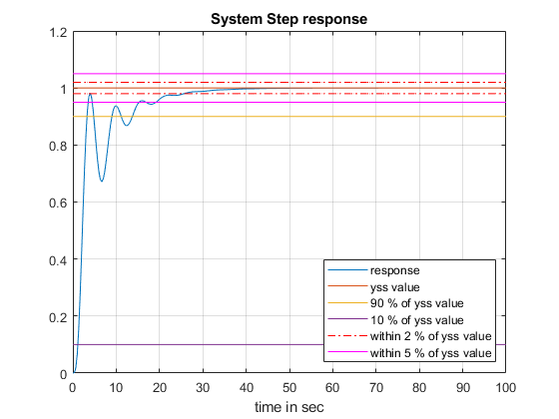

Figure 13: Steady State Response of PI Controller with Gain = 3

Table 8: Transient Response with Varying Time Constant Values

|  |  |  |  |  |  |  |  |
| --- | --- | --- | --- | --- | --- | --- | --- |
| **Operational Gain Value** “ $K_{P}$” | **Integral Time Constant $τ_{i}$** | **Steady State Output Value** “yss” | **Steady State Error** **Percentage** “ess”(%) | **Overshoot Peak Value** “PO” | **Percentage Overshoot** “PO” (%) | **TSettle 2%** (s) | **TRise 0-100%** (s) |
| 3.05 | 10 | 1 | 0 | 1.3598 | 35.98 | 99.33 | 2.34 |
| 3.05 | 3 | 1 | 0 | 0 | 0 | 19.06 | 36.45 |
| 3.05 | 1 | 1 | 0 | 0 | 0 | 10.03 | 15.38 |

Using the benchmarked Operational Gain value, the different time constants are used to test transient parameters. The benefit of the PI System can be observed as there is no Steady State Error, ensuring the system will always be at the reference point. It can be observed that as the Integral Time Constant increases, the parameters get worse. It is also worth noting that the PI Controller presents worse transient parameters in comparison to the P Controller, with the TSettle 2% and TRise 0-100%being considerably worse.

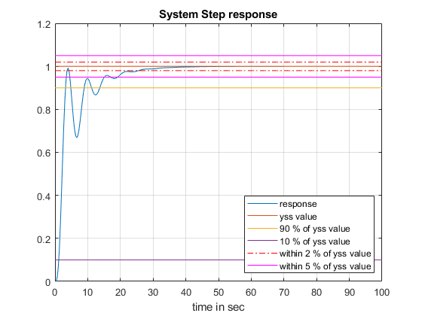

Figure 14: Steady State Response of PI Controller with Time Constant = 3

Table 9: Effect on Transient Response of PI Controller with Change in Gain and $τ_{i}$

|  |  |  |  |  |  |
| --- | --- | --- | --- | --- | --- |
| **Operational Controller Gain** | **ess Step** (%) | **ess Ramp** (%) | **PO** | **TSettle 2%** (s) | **TRise 0-100%** (s) |
| Gain increase | No change | Decrease | Increase | Increase | Decrease |
| Gain decrease | No change | Increase | Decrease | Decrease | Increase |
| increase | No change | No change | Increase | Increase | Decrease |
| $τ_{i}$ decrease | No change | No change | Decrease | Decrease | Increase |

**Proportional + Derivative (PD) Control**

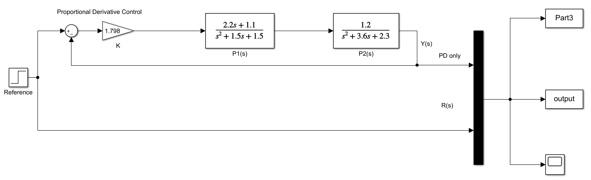

Figure 15: PD Controller SIMULINK Diagram

Proportional + Derivative (PD) is used to create a faster system response. The same principles applied to Proportional Control will be applied here again to study the PD response. It is important to note that a value of $τ_{d}=2$ was used to conduct these studies.

The transfer function used is as follows:

$$G_{CL}\left(s\right)=\frac{2.64K_{PD}s+1.32K_{PD}}{s^{4}+5.1s^{3}+9.2s^{2}+8.85s+3.45+2.64K_{PD}s+1.32K_{PD}}$$

The characteristic equation is: $s^{4}+5.1s^{3}+9.2s^{2}+8.85s+3.45+2.64K_{PD}s+1.32K_{PD}$

It was found that the Critical Gain ${(K}_{Crit})$ is 9.79

Different gain ${(K}_{P})$ values were used, and the results were tabulated in the following table:

Table 10: Steady State Error of PD Controller under Different Operational Gain

|  |  |  |
| --- | --- | --- |
| **Operational Gain Value** “ $K_{P}$” | **Steady State Output Value** “yss” | **Steady State Error** **Percentage** “ess”(%) |
| 1 | 0.2768 | 72.32 |
| 2 | 0.4335 | 56.65 |
| 3 | 0.5345 | 46.55 |
| 4 | 0.6049 | 39.51 |
| 5 | 0.6568 | 34.32 |
| 6 | 0.6966 | 30.34 |
| 7 | 0.7282 | 27.18 |
| 8 | 0.7534 | 24.66 |
| 9 | 0.7848 | 21.52 |

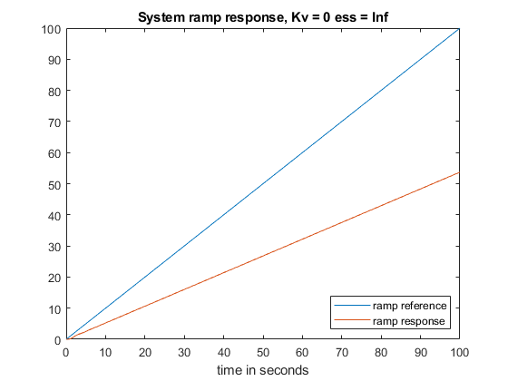

Figure 16: System Ramp Response of PD Controller

It can be seen while observing Figure 16 that the Ramp response of PD Controller is like that of a P Controller. This can be explained by the value “s” acting as a delay element, providing an infinite difference between the reference and the output. Hence, like the P Controller, the transient response is calculated from the Step Response.

Table 11: Transient Response of PD Controller with Different Operational Gain

|  |  |  |  |  |
| --- | --- | --- | --- | --- |
| **Operational Gain Value** “ $K_{P}$” | **Percentage Overshoot** “PO” (%) | **Overshoot Peak Value** “PO” | **TSettle 2%** (s) | **TRise 0-100%** (s) |
| 1 | 36.62 | 0.3781 | 7.02 | 1.6722 |
| 2 | 44.92 | 0.6282 | 6.68 | 1.3378 |
| 3 | 54.33 | 0.8248 | 9.03 | 1.3378 |
| 4 | 59.55 | 0.9651 | 11.37 | 1.3378 |
| 5 | 68.51 | 1.1067 | 13.71 | 1.0033 |
| 6 | 74.29 | 1.2141 | 18.39 | 1.0033 |
| 7 | 77.13 | 1.2898 | 25.75 | 1.0033 |
| 8 | 80.19 | 1.3575 | 43.81 | 1.0033 |
| 9 | 85.47 | 1.4555 | 99.33 | 1.0033 |

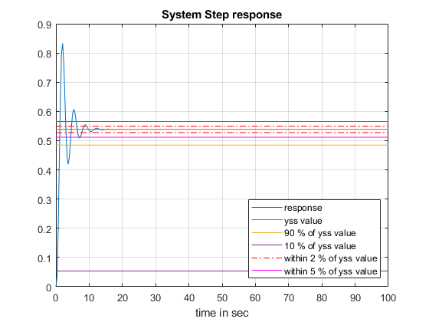

Figure 17: System Step Response for Gain = 3.05

Table 12: Transient Response with Varying Time Constant Values

|  |  |  |  |  |  |  |  |
| --- | --- | --- | --- | --- | --- | --- | --- |
| **Operational Gain Value** “ $K_{P}$” | **Time Constant $τ_{d}$** | **Steady State Output Value** “yss” | **Steady State Error** **Percentage** “ess”(%) | **Overshoot Peak Value** “PO” | **Percentage Overshoot** “PO” (%) | **TSettle 2%** (s) | **TRise 0-100%** (s) |
| 3.05 | 7 | 0.5388 | 46.12 | 1.37 | 155.25 | 54.18 | 0.66 |
| 3.05 | 3 | 0.5386 | 46.14 | 0.96 | 79.14 | 11.03 | 1.00 |
| 3.05 | 1 | 0.5386 | 46.14 | 0.71 | 32.25 | 8.69 | 1.67 |

Using the benchmarked Operational Gain value, the different time constants are used to test transient parameters. The benefit of the PD System can be observed as the rise time is extremely small in comparison to P Controller. There is however a constant Steady State Error. It can be observed that as the Time Constant increases, the settling time increases while the rise time decreases.

Table 13: Effect on Transient Response of PD Controller with Change in Gain and $τ_{d}$

|  |  |  |  |  |  |
| --- | --- | --- | --- | --- | --- |
| **Operational Controller Gain** | **ess Step** (%) | **ess Ramp** (%) | **PO** | **TSettle 2%** (s) | **TRise 0-100%** (s) |
| Gain increase | No change | Decrease | Increase | Increase | Decrease |
| Gain decrease | No change | Increase | Decrease | Decrease | Increase |
| increase | No change | No change | Increase | Increase | Decrease |
| $τ_{d}$ decrease | No change | No change | Decrease | Decrease | Increase |

**Part 2: PID Control**

For this design, the Ziegler-Nichols “Ultimate Gain” modified method was chosen. To construct the PID controller, a slightly more practical form of parallel structure was used. Only a single multiplier – the Proportional Controller gain $K_{P}$– is used with the integral and derivative channel parameters using the time constants.

$$G_{PID}\left(s\right)= K_{P}(1+\frac{1}{τ_{i}s}+τ_{d}s)$$

Design Specifications:

* Steady state error with a unit step input 𝑒𝑠𝑠(𝑠𝑡𝑒𝑝)%=0%
* Steady state error with a ramp input should be small as possible

(ramp) →0

* Percentage Overshoot (PO) of the response with unit step input should be less than 15%
* Setting time TSettle 2%should be one half or less than compared to the settling time of the benchmark

Procedure for "Ultimate Gain" Modified Method:

1. Make a Closed loop system with only Proportional Control.
2. Adjust the gain until a quarter-decay response is obtained. A quarter-decay response is when each amplitude of each following oscillation is one-fourth of the previous amplitude.
3. The gain for the quarter-decay response is now the ultimate gain KU. From the response, measure the period PU.
4. Calculate the time constants and proportional gain base on the table below

Table 14: Ziegler-Nichols “Ultimate Gain” Modified Tuning Method

|  |
| --- |
| $K_{U}$ = $K_{P}$ |
| $$τ_{i}= {P_{U}}/{1.5}$$ |
| $$τ_{d}= {P_{U}}/6$$ |



Figure 18: Steady State Response of P Controller when Kp = 3.05

Table 15: Ziegler-Nichols "Ultimate Gain" Parameters

|  |
| --- |
| $$K_{P}=3.05$$ |
| $$τ_{i}= {P_{U}}/{1.5}=3.5674$$ |
| $$τ_{d}= {P_{U}}/6=0.8918$$ |

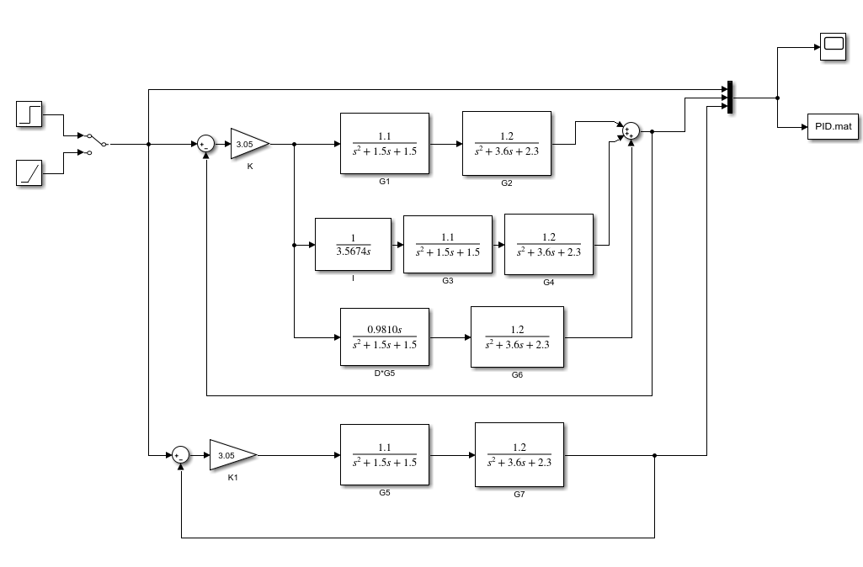

Figure 19: PID Controller

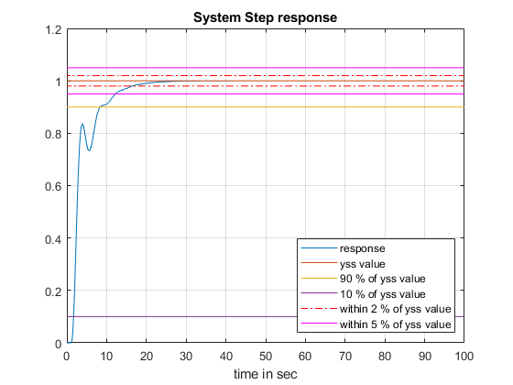

Figure 20: PID System Response

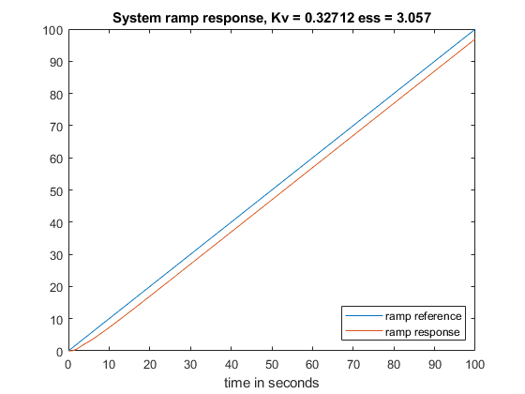

Figure 21: PID System Ramp Response

Table 16: Comparison Between the PID and the Benchmark Controller

|  |  |  |  |  |  |  |  |  |
| --- | --- | --- | --- | --- | --- | --- | --- | --- |
| **System Type** | **Steady State Output Value** “yss” | **Steady State Error** **Percentage** “ess Step”(%) | **Steady State Error** **Percentage** “ess Ramp”(%) |  | **Overshoot Peak Value** “PO” | **Percentage Overshoot** “PO” (%) | **TSettle 2%** (s) | **TRise 0-100%** (s) |
| PID | 1 | 0 | 3.05 | 0.3271 | 0 | 0 | 16.32 | 30.67 |
| Benchmark | 0.5386 | 46.14 | Inf | 0 | 0.7587 | 40.88 | 46.14 | 15.38 |

Comparing the two different systems, the PID Controller satisfies the specifications. The Steady State Error for Unit Step is 0%, Steady State Error for Unit Ramp is close to 0%, Percentage Overshoot is 0% and the Settling time is half of the benchmark system.

**Discussion**

**1.** Analysis of PI and PD systems in part 1, lead to the observation that the integrator component of the PI system generally decreased the step steady state error and the ramp steady state error due to the integrator’s ability to increase the system type. However, the derivative component of the PD system has no effect on the system type thus making it unable to change any steady state errors.

The implication for choosing the “best” settings of parameters is related to the ramp steady state error. This is because we have no control over the parameters that affect the ramp error. There is no implication in terms of the step steady state error since the error is always zero regardless of the chosen parameters, as observed in part 1.

**2.** Analysis of the PI and PD systems in part 1, lead to the observation that the integrator component of the PI system generally caused the PO to be less than that of the benchmarked P system. On the other hand, the derivative component of the PD system generally caused the PO to be higher than that of the benchmarked P system. For the PID controller, the gain of the controller, as well as the derivative time constant, are proportionally related to the PO, whereas the integral time constant is inversely proportional to the PO.

PI control adds an extra pole to the system, and if the location of the pole is close enough to the existing poles, it will have a noticeable effect on the system. The impact of this pole will be a slower system in terms of rise time, but it will also have reduced PO and smaller oscillations. If the pole is very close to the imaginary axis, it may become the dominant pole and, in this case, the response would be exponential, resulting in very slow rise and settling times, as well as no PO since there will be no oscillations. PD control adds an extra zero to the system, and if the location of the zero is close enough to have a non-negligible effect, the PO will be higher, but the rise time will be much faster.

The implications for choosing the “best” settings of parameters are that all the parameters that affect the PO will be fixed depending on the quarter decay gain of the given system, meaning that adjusting one parameter would require adjusting all the other parameters. That means that depending on the specifications that the tuning method was designed for, it may be not very relevant or application to all systems. For our desired PO requirement of less than 15%, the parameters obtained from the tuning method was applicable.

**3.** Analysis of the PI and PD systems in part 1, lead to the observation that the integrator component of the PI system decreases the settling time as the time constant decreased and the derivative component of the PD system decreases the settling time as the time constant decreased. Selecting low integral and derivative time constants causes the rise time to increase and the percent overshoot to increase.

In terms of settling time, we can clearly see the implications of choosing the “best” settings of parameters. While these settings improved the performance of the overall system, the settling time was not improved much. This shows that the goal of the tuning method was not to speed up the system response, but it was to eliminate steady state errors and percentage overshoots overall.

**4.** For the PID design, the rise time and percent overshoot decreased whereas the steady state response of the ramp is almost zero. This was done by utilizing all the controller modes into one controller called the PID controller. This controller utilizes the effects of PI and PD controllers to achieve an overall system response that achieved the specifications listed under requirements. The proportional controller, in theory, can achieve zero steady state error to a step response, at a cost of having an infinitely large proportional gain, which is unrealistic and will lead to instability. The derivative block’s time constant decreases both the percent overshoot and settling time, thereby helping the cause of achieving the specifications of less than 15% overshoot, and half the time taken of settling time from the benchmarked quarter decay response. The derivative predicts the behaviour of the system, thus improving settling time. Finally, as we are using a step input as a tracking signal, we had the integral block into the controller design, providing an extra pole. This extra pole allows your steady step error to become zero, which wasn’t possible with just a proportional controller. The integral block takes the integral of the instantaneous error over time and gives the accumulated offset to correct this error. These specifications were met using Ziegler-Nichols Method 2, “Ultimate Gain Method”, and calculations are shown in part 2 of the lab.

**References**

[1]"PID Controller Tuning Techniques | ECE Tutorials", *Ecetutorials.com*. [Online]. Available: http://ecetutorials.com/process-control/pid-controller-tuning-techniques/.